JZoomer User Guidance V1.1
by Marquis Hou<talent_marquis>
marquisx.tz@gmail.com

1. Screen Shots
1.1 Main frame
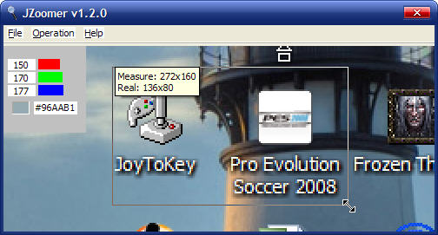
1.2 About dialog

1.3 Tray
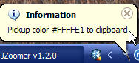
1.4 Popup menu
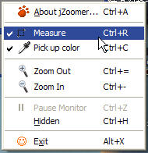

2. Function
2.1 Hot keys
Function | Hot key1 | Hot key2 | Description
Drag window | Mouse left button |  | Drag window
Drag widget | Ctrl+Mouse left button |  | Drag widget
Measure | Ctrl+R |  | Open/close measure function
Measure operation | Mouse left button drag |  | Measure operation(Measure Open)
Pickup color | Ctrl+C |  | Open/close color info panel
On/off show color info | Click mouse left button |  | On/off show color info (Pickup color Open)
Pickup color to clipboard | Double click mouse left button |  | Pickup color to clipboard (Pickup color Open)
Zoom out | Ctrl+= | Mouse scroll(up) | Max zoom rate: 8x
Zoom in | Ctrl+- | Mouse scroll(down) | Min zoom rate: -4x
Start/Pause Monitor | Ctrl+Z |  | Start/Pause zoom sample
Hidden | Ctrl+H | Click tray icon | Hidden mainframe into tray
Exit | Alt+X | Alt+X | Exit JZoomer

2.2 Configuration: system.properties

#======================================================
#jZoomer info
#======================================================
author = Marquis Hou
version = v1.2.0
#======================================================
#jZoomer init
#======================================================
init.width = 300
init.height = 200
min.width = 200
min.height = 150
#Background color:R,G,B
background.color = 200,200,200
#======================================================
#Zoom rate range
#======================================================
zoom.rate.max = 8
zoom.rate.min = -4
zoom.rate.default = 2
#======================================================
#Sample frequency of screen capture, unit: milliseconds
#======================================================
capture.millisecond = 50
#======================================================
#The scaling type, the higher the number is, the better
#the image quility but slower speed are.
#Number:1,2,4,8,16
#======================================================
image.scale.type = 1
#======================================================
#Whether or not the frame is always on top.
#======================================================
on_top = true
#======================================================
#Whether or not show tray prompt message
#======================================================
tray.message.show = true
#======================================================
#Whether or not the message box will be poped when exit.
#======================================================
exit.confirm = false
#======================================================
#The locale of jZoomer
#now you can choose two locales: zh_CN and en_US
#======================================================
support.locale = en_US,zh_CN
locale = en_US

